“Київський фаховий коледж зв’язку”

Циклова комісія Комп’ютерної та програмної інженерії

**ЗВІТ ПО ВИКОНАННЮ**

**Лабораторна робота №2**

з дисципліни: «Операційні системи»

**Тема: “Знайомство з інтерфейсом та можливостями ОС Linux”**

Виконав(ла/ли) студент(ка/и)

групи КСМ-13а

Команда “Better call Chekh”:

Тунда Р.О.

Бродзінський Є.В.

Кравченко Т.І.

Перевірив викладач

Сушанова В.С.

Київ 2023

**Мета роботи:**

1. Знайомство з інтерфейсами ОС Linux.

2. Отримання практичних навиків роботи в середовищах ОС Linux та мобільної ОС – їх графічною

оболонкою, входом і виходом з системи, ознайомлення зі структурою робочого столу, вивчення

основних дій та налаштувань при роботі в системі

**Матеріальне забезпечення занять**

1. ЕОМ типу IBM PC.

2. ОС сімейства Windows (Windows 7).

3. Віртуальна машина – Virtual Box (Oracle).

4. Операційна система GNU/Linux – CentOS.

5. Сайт мережевої академії Cisco netacad.com та його онлайн курси по Linux

**Завдання для попередньої підготовки**

***Готував матеріал студент Кравченко Т.І. та доповнив Бродзінський Є.В.***

***Tasks for preliminary preparation.***

1. Прочитайте короткі теоретичні відомості до лабораторної роботи та зробіть невеликий словник

базових англійських термінів з питань призначення команд та їх параметрів:

|  |  |
| --- | --- |
| Термін англійською | Термін українською |
| **Command Line Interface (CLI)** | Інтерфейс командного рядка |
| **GUI Terminal** | Графічний термінал |
| **Central Processing Unit (CPU)** | Центральний процесор |
| **Graphical user interface (GUI)** | Графічний інтерфейс користувача |
| **Distribution** | Дистрибутив (версія операційної системи) |
| **Performance** | Продуктивність |
| **Binary Translation** | Двійковий переклад |
| **Major Applications** | Основні програми |
| **Guest Operating System** | Гостьова операційна система |
| **UNIX-like Operating System** | Операційна система, подібна до UNIX |

2. Вивчіть матеріали онлайн-курсу академії Cisco “NDG Linux Essentials”:

- Chapter 3 - Working in Linux

- Chapter 4 - Open Source Software and Licensing

3. Пройдіть тестування у курсі NDG Linux Essentials за такими темами:

- Chapter 03 Exam

- Chapter 04 Exam

4.

* CLI mode is a text-based interface that allows users to interact with a computer system by entering commands and parameters through the command line, without using a graphical interface. In this mode, users can perform various tasks, manage the system, and execute commands to manage applications and resources. The CLI allows more control and capabilities compared to the GUI.
* A GUI-based terminal is a program or window in the graphical user interface of a computer system that mimics the functionality of a traditional text terminal or command line. It allows users to execute commands and interact with the operating system by entering text commands, similar to working in a regular text terminal, but using a graphical interface for user convenience.
* A virtual terminal is an emulation of a text terminal or command line on a computer system that allows users to interact with the system through a text interface even when they are using a graphical interface. Virtual terminals can be run and used in parallel with a graphical environment, and they allow you to run commands, check system status, and perform other text operations without having to switch to full-screen text mode.

5. Підготувати в електронному вигляді початковий варіант звіту:

- Титульний аркуш, тема та мета роботи

- Словник термінів

- Відповіді на п.5 та п.6 з завдань для попередньої підготовки

**Хід роботи.**

***Готували матеріал разом* Кравченко Т.І.(1.1-1.3) , Тунда Р.О.(2.3) Бродзінський Є.В. (2.1; 2.2;2.4)**

1. Робота в графічному режимі в ОС сімейства Linux (робота з інтернет-джерелами):

1.1.

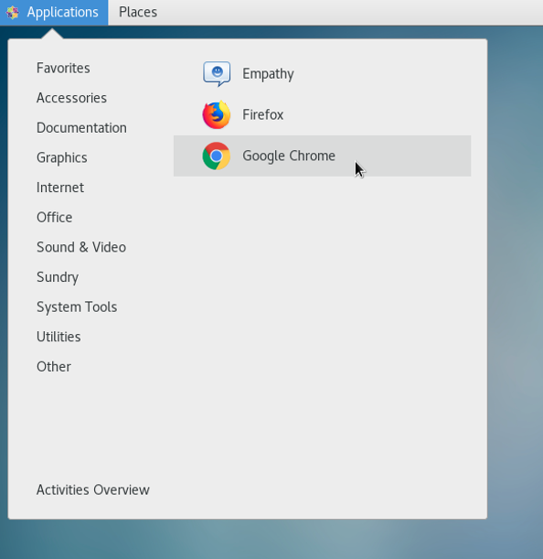-CentOS 7 (like GNOME) has an "Applications" menu in the upper left corner of the screen. In this menu, you can view and launch installed programs.

-Places tab Provides quick access to resources and directories in the file system, usually this tab has the following items: "Home", "Documents", "Downloads", "Music", "Pictures", "Videos", "Computer", and "Network".

1.2.

-Activities overview navigation space

Launch programs through menu search. You need to click on the Super button (it looks like Windows on the keyboard), the next thing we do is write the name of the program in the search field (in our case it is terminal) that needs to be opened, then the program is located and we can open it

-Launch programs through the quick launch bar: you need to click the left mouse button on the Program tab, then select the category and program.

- Launching programs through the launch widget: we find the launch widget, which is located at the bottom of the screen and contains the icons of the selected programs, then we need to find the icon of the program you need to open, click on the program icon, after that the entire program will start. (unfortunately, I did not find it, so I described how to do it)

- Launch programs through the global menu: you need to click the left mouse button in the upper part of the screen, where the time is located, after activating the global menu, you need to find the program you need and open it. (unfortunately, I did not find it, so I described how to do it)

1.3.

-Changing ser to root: first we needed to go to the terminal, then we write the command "su", write the password for root, and we changed the user to root.

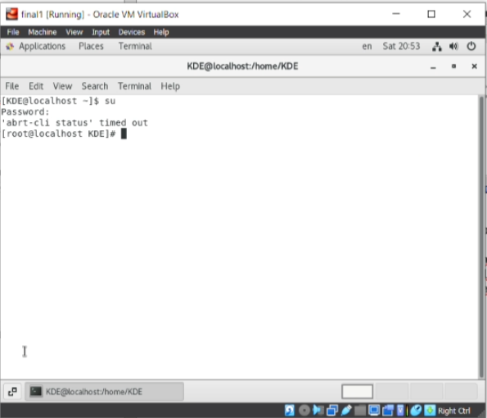

-Rebooting the system: go to the terminal and specify the "reboot" command, after which the system reboots.

Shutting down the system: open the terminal and write the "shutdown" command. after that, the system turns off after a while.

2. Work in a mobile OS environment.

2.1. Опишіть головне меню вашої мобільної ОС, який графічний інтерфейс вона використовує?

The main menu of the iOS mobile operating system used on Apple devices utilizes a graphical interface based on several key components, including the home screen. The iOS home screen is referred to as "Springboard," and it serves as the primary workspace of the device. The main components of the iOS home screen include:

1. **Apps**: The iOS home screen features app icons. Users tap on these icons to open the corresponding apps and programs. Apps can be organized into folders or placed directly on the home screen.
2. **Control Center**: At the top of the home screen, there is typically a Control Center panel that provides information about the time, network status, battery level, and other useful icons and indicators. Users can also interact with the Control Center to perform various actions, such as enabling Wi-Fi or Bluetooth.
3. **Widget Panels**: On the left side of the iOS home screen, there are widget panels that contain useful information, quick actions, and notifications. Widgets can be added and customized by the user to display relevant data.
4. **Dock**: The bottom part of the home screen contains the "dock," which includes app icons that users can access from any screen. The dock also includes an "App Store" icon for accessing the app store and other useful tools.
5. **Search**: Typically, the home screen has a search feature that allows users to quickly find apps, contacts, messages, and other information on the device.

The iOS graphical user interface is highly intuitive and user-friendly, making it easy for users to interact with various features of Apple devices. The home screen, known as Springboard, serves as the central hub for accessing all apps and functions.

2.1.Describe the main menu of your mobile OS, what GUI does it use?

Since my mobile device has IOS, I will describe IOS and the graphical interface of this OS:

The main menu of the mobile OS iOS uses a graphical interface that includes the following components:

1)Dock: At the bottom of the screen, there is a static panel (dock) with icons of core apps and quick access to them.

2)Home Screen: This is the starting page where app icons and widgets are placed. You can organize them in specific orders and create categories.

3)Control Center: Located at the top of the screen, this panel allows for quick control of functions such as Wi-Fi, Bluetooth, "Do Not Disturb" mode, brightness adjustment, and more.

4)Notifications: They appear at the top of the screen in the form of notifications and are then stored in the Notification Center.

5)Search: The built-in search application allows you to find content on your device and on the internet.

6)App Store: The "App Store" app allows you to download and install new applications.

2.2. Describe the mobile phone component settings menu.

Menu of settings of mobile phone components with OS IOS:

1)Dock: At the bottom of the screen, there is a static panel (dock) with icons of core apps and quick access to them.

2)Home Screen: This is the starting page where app icons and widgets are located. You can organize them in specific orders and create categories.

3)Control Center: Located at the top of the screen, this panel allows quick control of functions such as Wi-Fi, Bluetooth, "Do Not Disturb" mode, brightness adjustment, and more.

4)Notifications: They appear at the top of the screen as notifications and are then stored in the Notification Center.

5)Search: The built-in search app allows you to find content on your device and the internet.

6)App Store: The "App Store" app allows you to download and install new applications.

7)Sound and Haptics: Adjust sound settings, choose ringtones, configure vibrations, and customize message alert sounds.

8)Display & Brightness: Customize display settings, brightness, auto-brightness, and the True Tone feature.

9)Touch ID or Face ID and Passcodes: Manage authentication methods, set up passwords, PIN codes, Touch ID, or Face ID for device unlock and app authorization.

10)Accessibility: Includes various general options such as "Accessibility," keyboard settings, accessories, profiles, and VPN.

11)Apps: Configure settings for individual apps, change permissions, and access to features.

12)Battery: Check battery usage statistics and manage power consumption.

13): Manage privacy settings, permissions for apps and services.

14)iTunes & App Store: Adjust settings for App Store downloads, automatic app updates, and use your Apple ID account.

15)General: Displays device information, including software version, serial number, and available storage space.

2.3. Using keyboard shortcuts to perform special actions.

Touch screen gestures and combinations to perform special actions:

1) Double-Click Home Button: If your device has a Home button, double-clicking it is used to open a list of open apps or launch Apple Pay (if supported).

2) Screenshot (Screenshot): You can take a screenshot of your screen by pressing the Sleep/Wake button and the Volume Down button (for devices without a Home button) or the Home button and the Volume Down button ( for devices with a "Home" button).

3) Enabling VoiceOver or TalkBack: If you enable special accessibility modes (VoiceOver on iOS or TalkBack on Android), you can perform various gestures and combinations for navigation and interaction with the device.

One of the features of IOS is the AssistiveTouch function, which allows you to create your own gestures and combinations to perform various actions. You can enable it in "Settings" -> "Accessibility" -> "AssistiveTouch". After that, you can set special gestures like single tap, double tap, long press and others to perform different functions like opening context menu, lock screen, etc.

2.4. Sign in and shut down the device. Features of battery power settings.

To enter the system, you need to unlock the device. Unlocking the device: To unlock the device and log in, we have to tap or swipe up on the screen to see the lock screen. To further unlock the device, you need to enter a password or Face ID.

Shutdown/reboot: To turn off the device or reboot it, you need to press and hold the power button (Sleep/Wake button) along with one of the volume buttons (these buttons are shown in the photo)

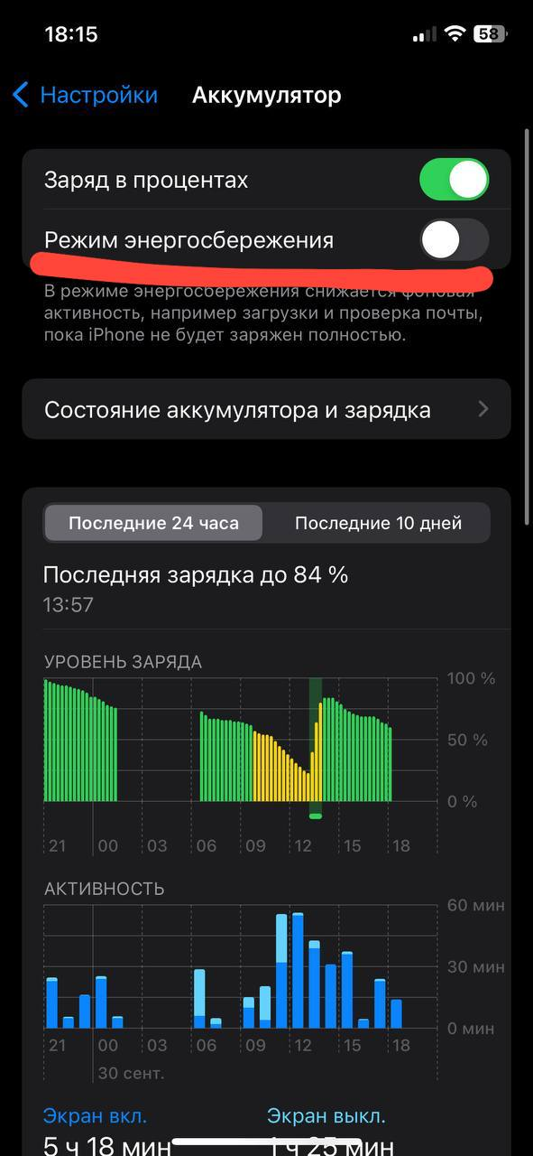Power Saver Mode: Power Saver Mode limits background activity of apps and features to extend battery life. You can turn it on in "Settings"

One of the features is that you can see battery charging statistics, activity statistics and activity in applications and battery usage in these applications in %

**Відповіді на контрольні запитання**

***Готував матеріал студент Тунда Р.О.***

1.Examples of Linux Server Applications:

* Database Servers: MySQL, PostgreSQL, Oracle Database, MongoDB.
* Mail Servers: Postfix, Sendmail, Exim, Dovecot (for IMAP/POP3).
* File Servers: vsftpd (FTP server), Samba (for file sharing in networks), ProFTPD, Pure-FTPd.

2.Comparison of Shells:

Bourne Shell (sh): Simple and limited in features. Has a basic set of functions.

C Shell (csh): Has syntax similar to C. Fewer features compared to Bash.

Bourne Again Shell (Bash): The standard shell for most Linux systems. Has a powerful syntax and many built-in features.

TENEX C Shell (tcsh): An extended version of the C Shell with additional features and command editing capabilities.

Korn shell (Ksh): A powerful shell with syntax similar to C. Has some extensions compared to Bash.

Z Shell (zsh): A highly advanced shell with multifunctional capabilities, including plugins and auto-completion.

3.Package Manager is used to manage the installation, updating, and removal of software packages on a Linux system. The advantages of package managers include automatic resolution of dependencies, ease of software installation and updates, and a convenient way to manage software.

Examples of package managers in Linux:

APT (Advanced Package Tool): Used in Debian and related distributions like Ubuntu.

YUM (Yellowdog Updater, Modified): Used in Red Hat, CentOS, and Fedora.

DNF (Dandified YUM): A newer package manager used in Fedora.

Pacman: Used in the Arch Linux distribution.

Zypper: Used in openSUSE.

4.Linux Security Tools include:

File Permissions and Ownership: Managing user/group permissions for files and directories.

Firewall (e.g., iptables or firewalld) for controlling network rules.

SELinux and AppArmor for restricting program access to resources.

File and Connection Encryption (SSH, HTTPS).

Auditing and Event Logging for monitoring the system for potential threats.

Antivirus Software for protection against viruses and malware (in some cases).

5.Virtualization has become popular due to factors such as:

Resource Efficiency: Virtualization allows better utilization of computational resources by dividing one physical server into multiple virtual machines.

Deployment Speed and Scalability: Virtual machines can be easily created, cloned, and scaled, simplifying the management of computing environments.

Isolation and Security: Virtual machines are isolated from each other, enhancing infrastructure security.

Backup and Recovery: Convenient backup and recovery of virtual machines.

Testing and Development: Virtual environments are ideal for software testing and development.

6.Containerization is a method of virtualization where individual applications and their dependencies run in isolated containers. They share the host OS kernel but have their own file systems and separate resources. Containers are lighter than virtual machines and offer easy application deployment and management.

7.Advantages of Open-Source Software:

Free Licensing: Typically, open-source software can be used and distributed for free.

Access to Source Code: Users can view and modify the source code, providing greater flexibility and control.

Active Developer Community: Open-source software often has a large community of developers and users who provide support and updates.

Security Auditability: Due to open-source nature, software can be audited for security.

8.

In Linux, there can be multiple active virtual consoles (terminals) by default. Typically, there are 6 terminals, labeled from F1 to F6. To switch between them, you can use key combinations like "Ctrl+Alt+F1" through "Ctrl+Alt+F6." For example, "Ctrl+Alt+F1" will switch you to the first terminal, "Ctrl+Alt+F2" to the second, and so on.

9.The graphical user interface in Linux typically runs on virtual console F7.

10.Yes, it is possible to register multiple times in a Linux system under the same username. This can be useful, for example, for remote SSH login from different devices or for multiple users working concurrently under the same account, such as on a remote desktop. Each login session for the same username will have its own separate processes and resources, and they do not interact with each other.

**Висновки:**

***In the course of the laboratory work, we conducted research and familiarized ourselves with the main aspects of the interfaces and capabilities of the Linux operating system. Practically, we learned the skills of running programs in Linux using various methods, such as the quick launch panel, menu search, launch widgets and the global menu. The possibility of logging in as root, rebooting and shutting down the system in the graphical interface was investigated.***

***Aspects of working in the mobile operating system were also considered. Practical skills of working in the Linux OS and mobile OS were obtained, as well as to deepen the understanding of the basic principles of working with the command line and graphical interface.***